**VCenter Server** is an application that enables you to manage your vSphere infrastructure from a centralized location. It acts as a central administration point for ESXi hosts and their respective virtual machines.

VCenter Server can be installed on a supported version of Windows or you can use a preconfigured Linux version known as**vCenter Server Appliance**. vCenter Server is required for some advanced vSphere features, such as vSphere High Availability, vSphere Fault Tolerance, vSphere Distributed Resource Scheduler (DRS), VMware vSphere vMotion, and VMware vSphere Storage vMotion.

A single vCenter Server instance can support a maximum of **1,000** hosts, **10,000** powered-on virtual machines and **15,000** registered virtual machines.

**How to install vCenter Server 6.5 on Windows Server 2012 R2 with an Embedded Platform Service Controller**

Download the VMware vCenter Server and Modules for Windows ISO from VMware downloads.

Mount the ISO and right click **autorun.exe**, select **Run as administrator**. The VMware vCenter Installer will open. Ensure vCenter Server for Windows is selected and click **Install**.

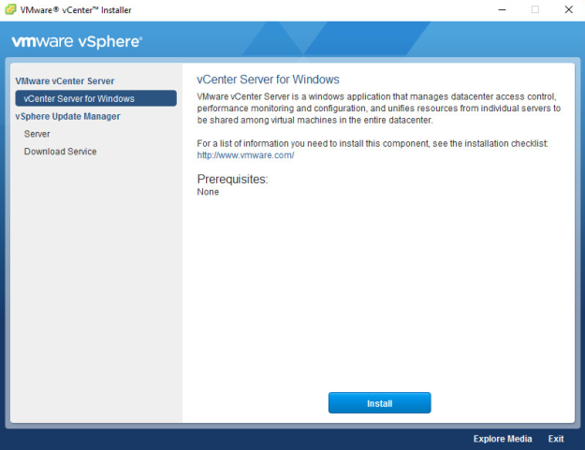

The vCenter Server 6.5 Installer will open in a separate window, click **Next**.

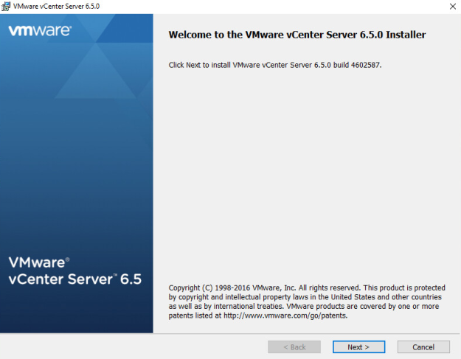

Accept the end user license agreement and click **Next**.

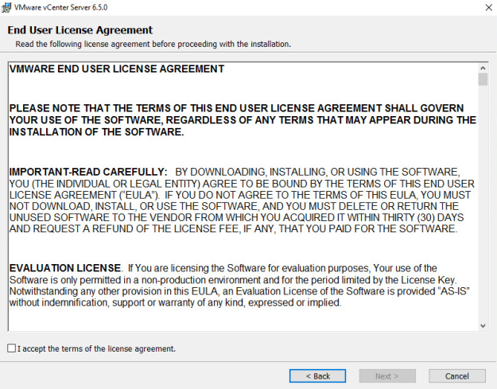

Select the deployment type and click **Next**. If the Windows server does not have sufficient resources allocated the installer will error at this stage.

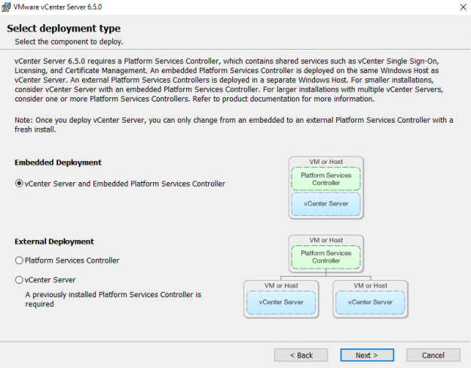

Enter the FQDN in the **System Name** field (That is local windows IP or FQDN) and click **Next**.

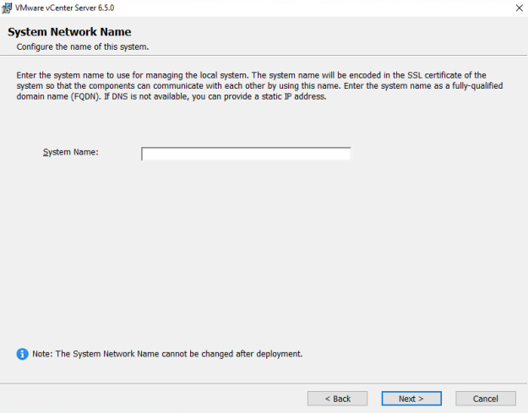

Create a new Single Sign-On domain. And Configure a password for the SSO administrator account and a vCenter specific site name, click **Next**. (Default user is administrator for SSO)

This credentials will help you for login with SSO in web clinet.

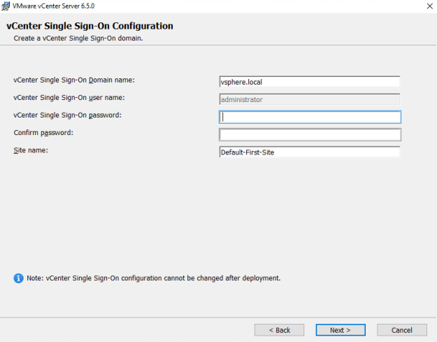

Click on next,

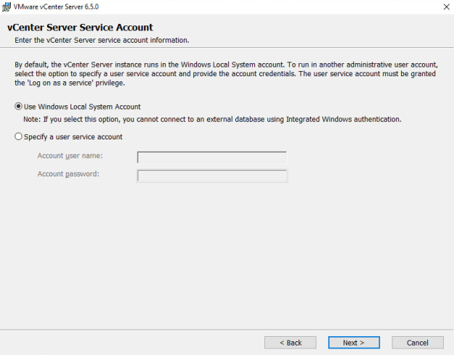

Select an embedded Postgre database or point the installer to the DSN for an external database, click **Next**.

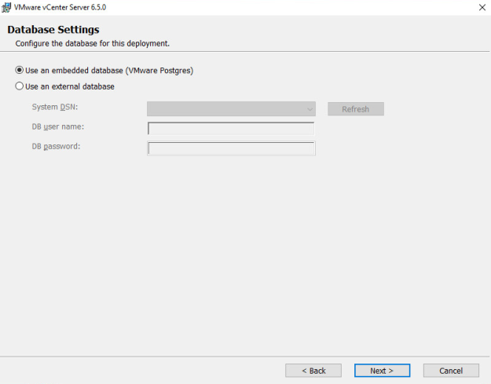

Accept the default port configuration and click **Next**.

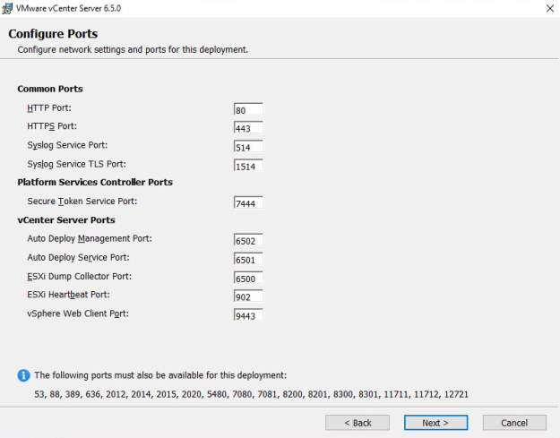

Select the directory to install vCenter services and click **Next**.

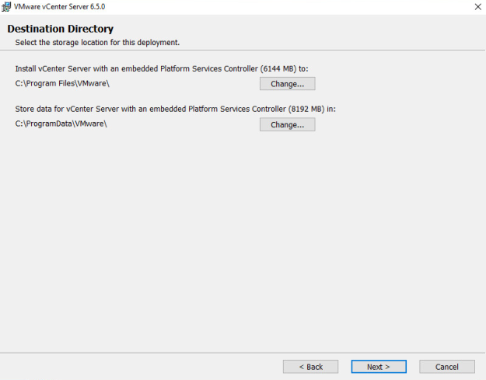

Tick or untick the VMware Customer Experience Improvement Program as appropriate and click **Next**.

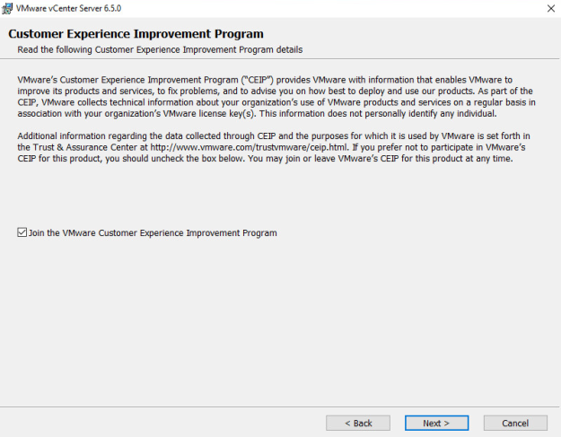

Check the configuration on the review page and click **Install** to begin the installation process.

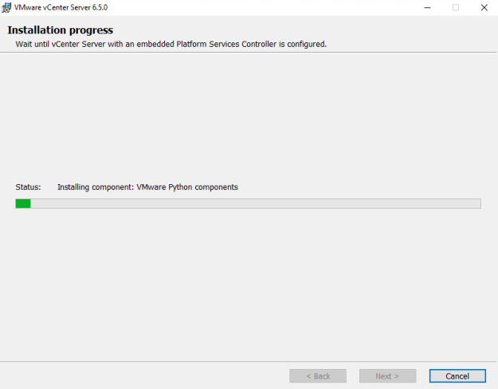

Once the installation has completed click **Finish**.

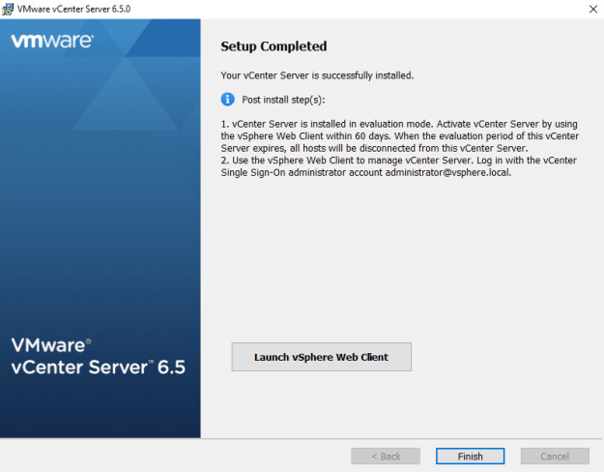

Connect to the vCenter post install using the IP or FQDN of the vCenter. Access vSphere by clicking either the **vSphere Web Client (Flash)** or the **vSphere Client (HTML5)**. Connect to the vSphere Web Client to manage your system, the thick client (Windows) is no longer supported.

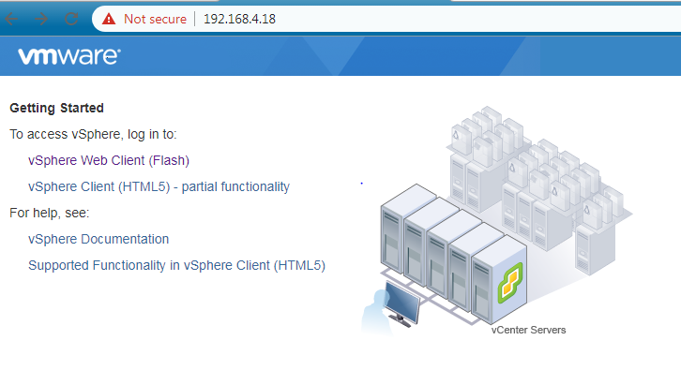

Click on vSphere web Client, will get web page with SSO login.

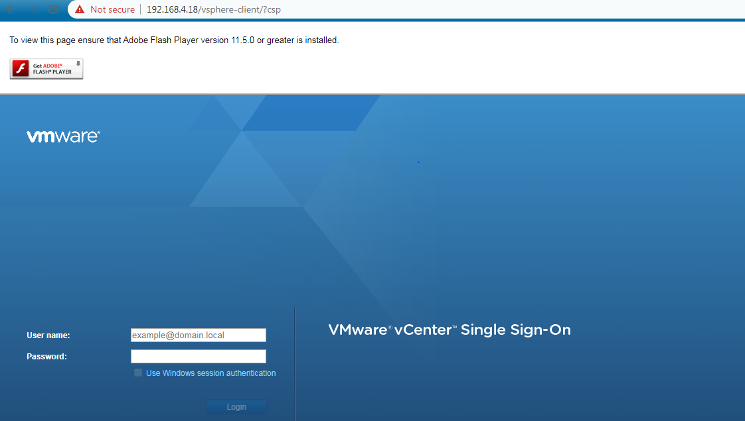

Once will login with credentials (administrator@vsphere.local is default user) will get VMware VCenter console page.

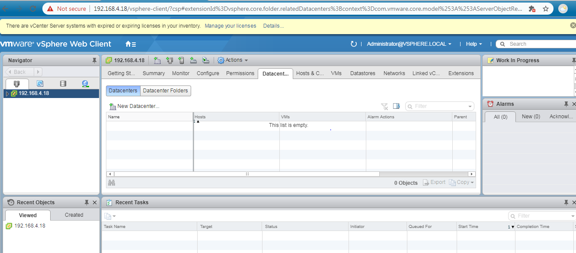

**Features of VCenter,**

1. VMotion,

Live Migration of VM Resources (CPU and Memory/RAM) from One Host to Another Host.

• No Downtime is required.

• Online Activity (No need to Power Off VM).

• Online Migration.

1. SVMOTION

• Live Migrating the VM Files from one Data Store to Another Data Store.

• No Downtime Required.

• Online Activity.

• Takes long time to migrate

Pre-Requirements For SVmotion.

• Minimum 2 Data Store in a Cluster.

• Should be same CPU Family.

• VM Kernel Port Group should be Enable

3)High Availability (HA)

• Whenever the Host is down all VMs will Power Off and transferred to Another Host and Power On/Reboot.

3 reasons for HA.

Host Failure Mechanism – Whenever Host Failed (Host will be rebooted again and again until it is connected)

o VM Failure Mechanism (VM restart Priority) – Whenever Single VM is failed (VM will be rebooted again and again until it is connected)

o Application Mechanism Failure – Whenever application is failed (Application will be restarted again and again until it is corrected)

• Down Time is required. • Offline Activity.

Pre-Requirements For HA.

• Minimum 2 ESXi hosts in a Cluster. • Should be same CPU Family. • Common Data Store. • VM Kernel Port Group should be Enable.

1. Distributed Resource Scheduler (DRS) – Cluster Future

Whenever Resources of VM is putting High Burden on ESXi Host. At that time DRS come into picture and migrate VM from Source Host to Destination Host without any Downtime Requirement.